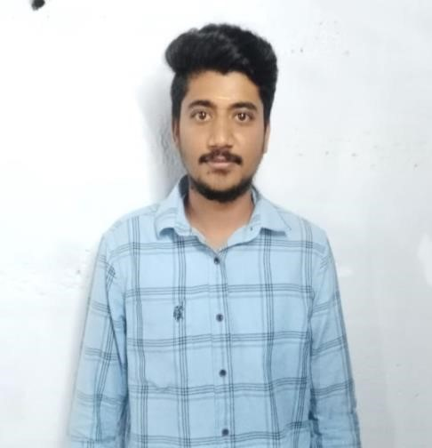

.



ADHIKESH K N

COMPUTER

APPLICATIONS

(

BCA

)

**Contact:**

Ph

.no

9786005558

Mail Id

:

adhikesh93@gmail.com

552

/

3

KUPPANDAMPALYAM,

VEERAPA,

NDI,

,

Tirupur 641

-

605

**TECHNICAL**

**SKILLS:**

C and C++

Java

**CE**

**RTIFICATES**

**:**

Linked in

Karate

**PERSONAL**

**TRAITS:**

•

Positive minded

•

Critical thinking &

problem

solving

•

A good initiator.

EDUCATION

Bachelors of

COMPUTER

A

PPLICATIONS

BCA

(

)

Nandha Art

s And Science

College

2023

-

26

with the

percentage of

%

73

Hsc 2nd y

Year in

,

Jayanthi Matric

ulation Higher

Secondary School

in 2022

-

23

In the group of

COMPUTER

APPLICATIONS

with percentage

of 82%

SSLC in,

Jayanthi

Matriculatio

ation

Higher Secondary School

in 20

20

-

2

1

With the percentage of

%

INTERNSHIP

web development

course

DECLARATION

:

I

hereby

furnishing

the

above

details

are

true to the best of

my

knowledge





